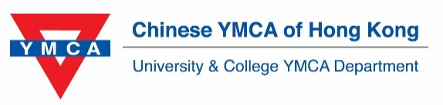

Dream Hunter Award 2020
~Dream Big, Fly High!~

About Dream Hunter Award
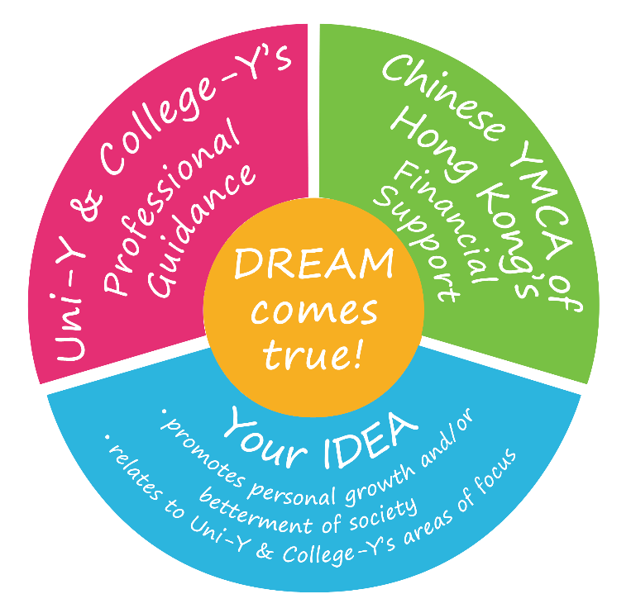
The Award aims to:
- encourage youth to pursue and realize dreams that would promote their personal growth and/or betterment of local and global communities;

- establish a platform for youth to dream out loud as they share their aspirations to inspire others; and

- empower youth to plan, coordinate, and set goals to actualize their dreams with a high degree of autonomy and professional guidance from staff of University & College YMCA Department.

About University & College YMCA
Embracing the mission of Chinese YMCA of Hong Kong, “To Serve, not to be Served”, University & College YMCA strives to nurture young leaders with strong leadership, broad global outlook, and a passionate heart to serve the society. With the facilitation of professional staff from Chinese YMCA of Hong Kong who are stationed on campus, each University YMCA (Uni-Y) or College YMCA (College-Y) is run by a student executive committee specializing in the following three main areas of focus:

Area of Focus | Objective
Global Citizenship | Increase students’ understanding and awareness of global issues;  broaden their global horizons and nurture them to become global citizens.
Community Engagement | Promote students’ understanding and public awareness of local issues and  social phenomena; strengthen students’ commitment to the underprivileged; foster their passion for community services.
Christian Action | Guide students to reflect on the meaning of life; increase their understanding on Christianity and practice Christian faith.

Award Details
 | Eligibility | Full-time tertiary students and alumni aged 18 to 30 with valid Uni-Y / College-Y membership  *Please ensure that all applicants must be valid Uni-Y/College-Y members before application.
 | Project Requirement | Relates to the area(s) of focus of University & College YMCA
 | Application & Selection Process | - Submit completed application (including application form, proposal and video/proposal for dummies) as an individual or a team of two to three  * Application form and proposal template are downloadable at http://uniy.ymca.org.hk/zh-hant  - Shortlist applications:  - Videos/Proposal for dummies will be posted online for public voting  - Applicants will be invited to a screening interview
 | Judging Criteria | *Priority is given to innovative projects or projects related to body-mind-spirit holistic well-being
 | Awards | - Non-Asian countries: Up to $12,000/ person  - Asian countries: Up to $8,000/ person  (Certificate will be issued upon satisfactory completion of project)
Completion Requirements (for award winners):
1. Before your trip:  - Consult with YMCA staff  - Attend award presentation & sharing session  - Submit a finalized proposal | 2. During your trip:  - Share your experience on social media  - Actualize your project  - Produce a short video (around 1 min) to capture the memorable moments | 3. After your trip:  - Submit photos and video  - Complete a report  - Attend evaluation meeting  - Attend sharing session
Timeline:

2020
7 Feb | Application deadline |  | 14 Mar | Award presentation
10 – 17 Feb | Public voting on submitted videos |  | Jun – Aug | Execution of the project
19 – 21 Feb | First Round Interview |  | 1 month after the trip | Submission photos and video
5 Mar | Final Interview |  | Before 31 Oct | Completion of a report and attend evaluation meeting
 |  |  | Nov | Attend sharing session
Enquiry:
Tel: 2705 2231 Email: dreamhunter@ymca.org.hk
Application Checklist

A completed application including the 3 items below should be emailed to dreamhunter@ymca.org.hk by 7 February 2020 (Fri). After that, You will receive a confirmation email.

- Application Form

- Project Proposal:
- Proposal template is downloadable at http://uniy.ymca.org.hk/en.
- Please follow the instructions in the template and include as much details as possible to facilitate our understanding and assessment of the proposal.

- Video/ Proposal for Dummies: (Please upload the file to google drive and submit the relevant link)
- The content should include:
  - Organizer (University & College YMCA Department, Chinese YMCA of Hong Kong) & Programme Name (Dream Hunter Award 2020)
  - Project Title (max. 20 words)
  - your self-introduction, objective and description of your project including but not limited to the visiting country, duration, etc.
  - the project’s relevancy to the area(s) of focus of University & College YMCA
  - text, image, acting or cross-media elements
- The video format should fulfill the following criteria:
  - length: 1 minute to 1 minutes 30 seconds
  - language/ voice-over: Cantonese, Mandarin or English
  - output requirements:
    - in video or computer animation production including editing and audio-visual treatment
    - MP4, AVI, MPEG, MOV, or WMV with resolution not lower than 720 x 576 pixels
    - file size: no more than 100MB
- The proposal for dummies should fulfill the following criteria:
  - 4 jpg files
  - output requirements:
    - only jpg will be accepted (Resolution not lower than 720 x 960 pixels)
    - file size: no more than 3MB/jpg
- The video/proposal for dummies will be uploaded to social media for public voting.

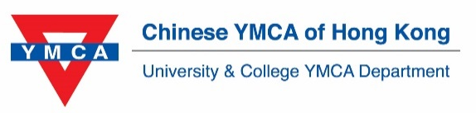

Dream Hunter Award 2020
~Dream Big, Fly High!~

Application Form

Please complete the form and email to dreamhunter@ymca.org.hk by 7 February 2020 (Fri). After that, you will receive a confirmation email.
*Only our members are valid to apply this award.
To become our member, please visit https://uniy.ymca.org.hk/zh-hant/node/17
- Entry Information
Individual Group

- Applicant Information
- Applicant 1 (Contact person)
Name  Same as HKID / Passport | (Chinese) | (English)
Date of Birth | (dd/mm/yy) | Contact No.
E-mail
University/ College  (CUHK students please specify your college) |  | Student No.
Faculty |  | Year of Study
Membership No. |  | Expiry Date | (dd/mm/yy)

- Applicant 2
Name  Same as HKID / Passport | (Chinese) | (English)
Date of Birth | (dd/mm/yy) | Contact No.
E-mail
University/ College  (CUHK students please specify your college) |  | Student No.
Faculty |  | Year of Study
Membership No. |  | Expiry Date | (dd/mm/yy)

- Applicant 3
Name  Same as HKID / Passport | (Chinese) | (English)
Date of Birth | (dd/mm/yy) | Contact No.
E-mail
University/ College  (CUHK students please specify your college) |  | Student No.
Faculty |  | Year of Study
Membership No. |  | Expiry Date | (dd/mm/yy)

C. Declaration

I/We, the applicants of Dream Hunter Award 2020,
- understand and agree to be abided by the conditions of entry, procedures, and judging methods in this scheme;
- declare that all the information given in this application form are correct and accept that information provided will be used in connection with the competition;
- declare that the submitted project and video are original works that have never been published before and do not infringe any rights of intellectual property of any other persons;
- agree that University & College YMCA reserves all copyrights and owner’s rights of the photos and videos I/we submitted;
- agree that University & College YMCA reserves the right to accept and/or reject any entries and has the authority to amend any judging criteria deemed necessary;
- agree that the decision of University & College YMCA shall be final, in case of any disputes over the result of Dream Hunter Award;
- agree that University & College YMCA reserves the right to make any final decision of not shortlisting any applicant and/or giving any award; and
- understand and agree to “Personal Information Collection Statement”: Chinese YMCA of Hong Kong undertakes to comply with the requirements of the Personal Data (Privacy) Ordinance to ensure that personal data kept are accurate and secure. Your personal information (including your name, email address, etc) may be used by Chinese YMCA of Hong Kong for the purposes of sending you organizational updates, fundraising appeals, event invitations, surveys and other communication and marketing via telephone/post/electronic mails. If you do not wish to receive any communication from us, please email your Chinese and English full name, together with your membership number and telephone number to University & College YMCA Department at uniycy@ymca.org.hk. For any enquiries, please contact us at 2705-2231.

Signature(s) | (1) |  | (2)
 | (3)

Name of Applicant(s) | (1) |  | (2)
 | (3)

Date | (1) |  | (2)
 | (3)

Dream Hunter Award 2020
~Dream Big, Fly High!~

Proposal
1. Applicant Information

(1) | Name：_______________ | Student No.： | ______________ | University/ College： | ______________
(2) | Name：_______________ | Student No.： | ______________ | University/ College： | ______________
(3) | Name：_______________ | Student No.： | ______________ | University/ College： | ______________
2. Project Background

Project Title
Rationales and Objectives
Overview
(max. 200 words)
Area(s) of Focus  *priority is given to innovative project or project related to body-mind-spirit holistic well-being | Global Citizenship Community Engagement Christian Action  Please elaborate on how your dream relates to the above area(s) of focus:
Evaluation Methods | Please describe how you would evaluate whether you have actualized your dream:

3. Project Details
Country / City:
Project Duration:

3.1 Itinerary (Please describe in details):
Date | Country/  City | Contents | Aim(s) | Relevant Organization(s)  (if any)

3.2 Risk management:

Expected difficulty | Solution
1.
2.
3.
4.
5.
6.
7.
8.
9.
10.

- Budget

Expense | Unit Cost  (HKD$) | Quantity | Subtotal  (HKD$) | Proposed subsidy from YMCA
e.g. Accommodation – Wu Kwai Sha Youth Village | $200/night | 5 nights | $1,000 | $1,000
Total |  |  | $1,000 | $1,000

Have you applied or do you intend to apply for additional funding from other sources for this project?
Yes, please specify:________________ No

The End

